[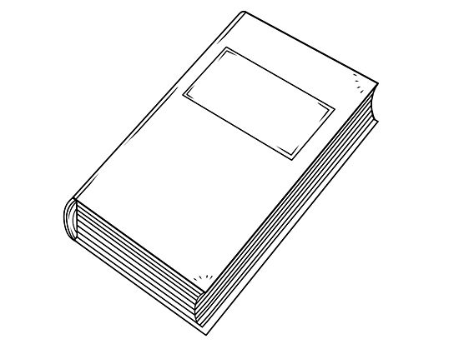](http://www.google.co.uk/url?sa=i&rct=j&q=&esrc=s&frm=1&source=images&cd=&cad=rja&docid=g8V8XHvxHduYsM&tbnid=vo-zCm-YiXrqZM:&ved=0CAUQjRw&url=http://www.wikihow.com/Draw-a-Book&ei=RfriUdjSCOfT0QWGnoDICA&bvm=bv.48705608,d.d2k&psig=AFQjCNGH3U82lIn_QatvMm6-Zj6e4ipZiw&ust=1373916067889619)

**2017 – 2018 Memory Page**

My favourite story book was _____________

________________________

________________________

[](http://www.google.co.uk/url?sa=i&rct=j&q=&esrc=s&frm=1&source=images&cd=&cad=rja&docid=NP6da6rLC1wJAM&tbnid=JY83SZPzTbHNhM:&ved=0CAUQjRw&url=http://www.123rf.com/photo_4010862_plate-fork-knife--dinnerware.html&ei=JffiUZ-TGaan0wWjsIC4Cg&bvm=bv.48705608,d.d2k&psig=AFQjCNHw6FtZHGFeGR9P17-R51EEsxIM0Q&ust=1373915258640479)[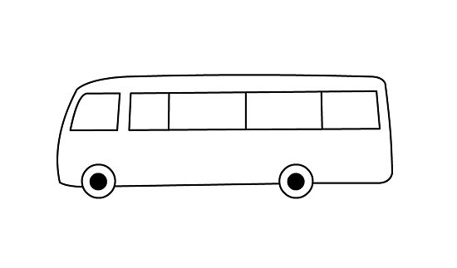](http://www.google.co.uk/url?sa=i&rct=j&q=&esrc=s&frm=1&source=images&cd=&cad=rja&docid=mrCYKsBFTTaO6M&tbnid=pq_Jfm1ziOKLQM:&ved=0CAUQjRw&url=http://www.wikihow.com/Draw-a-Bus&ei=B_jiUfZ65ZHRBbCcgbgO&bvm=bv.48705608,d.d2k&psig=AFQjCNGJFSgh3PhfXh1HM458Cl-cWfT0qA&ust=1373915517145099)

My favourite school lunch was ______________

_________________________

The best thing that happened to me was ______________

___________________

____________________

My favourite trip was ________________

_____________________